|  |  |  |  |  |  |
| --- | --- | --- | --- | --- | --- |
| Table 1: Sample Means for Project STAR Students and Classes by Year of Entry and Initial Class Type | | | | | |
|  | (1) | (2) | (3) | (4) | (5) |
| Panel A: Students who Entered STAR in Kindergarten | | | | | |
|  | Small | Regular | Regular/Aide | Joint P-Value | Within-school Joint P-value |
| Free lunch | 0.471 | 0.480 | 0.501 | 0.128 | 0.484 |
| White/Asian Student | 0.683 | 0.674 | 0.658 | 0.249 | 0.639 |
| Age on October 1, 1985 | 5.058 | 5.050 | 5.054 | 0.664 | 0.806 |
| Class size in kindergarten | 15.12 | 22.37 | 22.75 | 0.000** | 0.000** |
| Urban school | 0.305 | 0.309 | 0.325 | 0.585 |  |
| White/Asian teacher | 0.861 | 0.805 | 0.851 | 0.529 | 0.363 |
| Teacher has postgraduate degree | 0.313 | 0.364 | 0.363 | 0.638 | 0.556 |
| Teacher experience | 8.911 | 9.049 | 9.745 | 0.550 | 0.296 |
| Special education in kindergarten | 0.038 | 0.031 | 0.029 | 0.246 | 0.424 |
| Special instruction in kindergarten | 0.056 | 0.041 | 0.045 | 0.078* | 0.112 |
| Days present in kindergarten | 156.4 | 156.9 | 156.1 | 0.556 | 0.184 |
| Days absent in kindergarten | 10.02 | 10.53 | 10.87 | 0.019** | 0.015** |
| Missing data | 0.012 | 0.025 | 0.024 | 0.002** | 0.015** |
|  |  |  |  |  |  |
| Observations (Nonmissing) | 1,878 | 2,139 | 2,178 | 6,195 | 6,195 |
| Observations (Total) | 1,900 | 2,194 | 2,231 | 6,325 | 6,325 |
| Classrooms | 127 | 98 | 98 | 323 | 323 |
| Schools | 79 | 78 | 79 | 79 | 79 |
|  |  |  |  |  |  |
| Panel B: Students who Entered STAR in First Grade | | | | | |
|  | Small | Regular | Regular/Aide | Joint P-Value | Within-school Joint P-value |
| Free lunch | 0.595 | 0.626 | 0.606 | 0.513 | 0.407 |
| White/Asian Student | 0.612 | 0.556 | 0.651 | 0.000** | 0.145 |
| Age on October 1, 1985 | 5.380 | 5.481 | 5.503 | 0.003** | 0.011** |
| Class size in first grade | 15.78 | 22.70 | 23.36 | 0.000** | 0.000* |
| Urban school | 0.318 | 0.326 | 0.317 | 0.967 |  |
| White/Asian teacher | 0.816 | 0.780 | 0.795 | 0.851 | 0.561 |
| Teacher has postgraduate degree | 0.316 | 0.332 | 0.369 | 0.764 | 0.742 |
| Teacher experience | 12.88 | 10.04 | 12.17 | 0.096* | 0.026** |
| Special education in first grade | 0.011 | 0.022 | 0.025 | 0.178 | 0.439 |
| Special instruction in first grade | 0.187 | 0.238 | 0.205 | 0.073* | 0.068* |
| Days present in first grade | 130.9 | 139.5 | 142.0 | 0.000** | 0.000* |
| Days absent in first grade | 8.360 | 7.779 | 7.781 | 0.527 | 0.947 |
| Missing data | 0.070 | 0.052 | 0.066 | 0.266 | 0.459 |
|  |  |  |  |  |  |
| Observations (Nonmissing) | 358 | 973 | 843 | 2,174 | 2,174 |
| Observations (Total) | 385 | 1,026 | 903 | 2,314 | 2,314 |
| Classrooms | 106 | 115 | 98 | 319 | 319 |
| Schools | 68 | 76 | 71 | 76 | 76 |
|  |  |  |  |  |  |
| Panel C: Students who Entered STAR in Second Grade | | | | | |
|  | Small | Regular | Regular/Aide | Joint P-Value | Within-school Joint P-value |
| Free lunch | 0.650 | 0.621 | 0.652 | 0.499 | 0.677 |
| White/Asian Student | 0.574 | 0.568 | 0.490 | 0.012** | 0.356 |
| Age on October 1, 1985 | 5.526 | 5.550 | 5.577 | 0.544 | 0.227 |
| Class size in second grade | 15.50 | 23.62 | 23.74 | 0.000** | 0.000** |
| Urban school | 0.332 | 0.328 | 0.394 | 0.357 |  |
| White/Asian teacher | 0.779 | 0.737 | 0.737 | 0.791 | 0.603 |
| Teacher has postgraduate degree | 0.296 | 0.303 | 0.535 | 0.005** | 0.008** |
| Teacher experience | 12.60 | 12.61 | 13.48 | 0.768 | 0.788 |
| Missing data | 0.096 | 0.106 | 0.164 | 0.001** | 0.121 |
|  |  |  |  |  |  |
| Observations (Nonmissing) | 331 | 585 | 551 | 1,467 | 1,467 |
| Observations (Total) | 366 | 654 | 659 | 1,679 | 1,679 |
| Classrooms | 111 | 95 | 98 | 304 | 304 |
| Schools | 70 | 69 | 72 | 73 | 73 |

Notes to Table 1: Data source is Project STAR dataset. Tables are structured after Tables 1 and 2 of Krueger (1999) but with different variables and sample definitions. Small, regular, and regular/aide indicate the student’s class type in the first year in Project STAR. “Special instruction” indicates that student was pulled out for special instruction in that grade. Urban school and teacher characteristics are measured for the first year the student was in Project STAR. Data on special education, special instruction, days present, and days absent are not available for second grade. Sample includes those observations with non-missing values for the variables shown; sample for the “missing data” dummy includes all observations. Schools that left the program by third grade are excluded from the sample. For students entering Project STAR in kindergarten and first grade, most of the missing observations come from missing data on special education or instruction or days present or absent. For students entering the program in second grade, the missing observations come from missing data on free lunch, race, and teacher experience. Column (4) shows the p-value for an F-test of the null hypothesis that the means are equal across the three groups; ** indicates that the null hypothesis is rejected at the 5% significance level, and * indicates that the null hypothesis is rejected at the 10% level. Column (5) shows the p-value for the same F-test after controlling for fixed effects for students’ schools in their first year in the program. For individual student characteristics (free lunch, white/Asian student, special education, special instruction, days present, days absent, and missing data), robust standard errors are used. For urban school, the standard errors adjust for clustering at the school level, and for the classroom-level variables (class size, white/Asian teacher, teacher has postgraduate degree, and teacher experience), the standard errors adjust for clustering by teacher (the id of the teacher for the first year in the program).

|  |  |  |  |  |  |  |  |  |  |  |  |  |
| --- | --- | --- | --- | --- | --- | --- | --- | --- | --- | --- | --- | --- |
| Table 2: OLS Estimates of Effects of Class Type on Attrition | | | | | | | | | | | | |
|  | (1) | (2) | (3) | (4) | (5) | (6) | (7) | (8) | (9) | (10) | (11) | (12) |
| Panel A: Entered Project STAR in Kindergarten, Clusters = 307 | | | | | | | | | | | | |
| Initial Class Type | Changed School in First Year | | Changed Class Type within School in First Year | | Recommended to Repeat in First Year | | Changed School by Third Grade | | Changed Class Type within School by Third Grade | | Recommended to Repeat by Third Grade | |
| Small | -0.033 | -0.048 | -0.316 | -0.315 |  |  | -0.008 | -0.024 | -0.269 | -0.263 | -0.017 | -0.012 |
|  | (0.023) | (0.013)** | (0.018)** | (0.016)** |  |  | (0.026) | (0.013)* | (0.016)** | (0.013)** | (0.012) | (0.009) |
|  |  |  |  |  |  |  |  |  |  |  |  |  |
| Regular | -0.006 | -0.017 | 0.029 | 0.030 |  |  | 0.020 | 0.007 | -0.071 | -0.063 | 0.000 | 0.001 |
| w/ Aide | (0.023) | (0.012) | (0.022) | (0.019) |  |  | (0.027) | (0.012) | (0.018)** | (0.013)** | (0.013) | (0.009) |
|  |  |  |  |  |  |  |  |  |  |  |  |  |
| R2 | 0.001 | 0.097 | 0.116 | 0.141 |  |  | 0.001 | 0.119 | 0.074 | 0.114 | 0.001 | 0.052 |
|  |  |  |  |  |  |  |  |  |  |  |  |  |
| Panel B: Entered Project STAR in Grade 1, Clusters = 314 | | | | | | | | | | | | |
| Small | 0.064 | 0.058 | -0.112 | -0.113 | -0.021 | -0.007 | 0.050 | 0.039 | -0.133 | -0.132 | -0.039 | -0.022 |
|  | (0.030)** | (0.026)** | (0.023)** | (0.022)** | (0.022) | (0.019) | (0.034) | (0.029) | (0.022)** | (0.021)** | (0.024) | (0.020) |
|  |  |  |  |  |  |  |  |  |  |  |  |  |
| Regular | -0.013 | -0.003 | -0.062 | -0.049 | -0.030 | -0.018 | -0.015 | 0.004 | -0.095 | -0.091 | -0.048 | -0.030 |
| w/ Aide | (0.022) | (0.016) | (0.027)** | (0.018)** | (0.018)* | (0.013) | (0.027) | (0.019) | (0.025)** | (0.020)** | (0.020)** | (0.015)** |
|  |  |  |  |  |  |  |  |  |  |  |  |  |
| R2 | 0.004 | 0.068 | 0.022 | 0.189 | 0.002 | 0.103 | 0.002 | 0.093 | 0.034 | 0.147 | 0.004 | 0.100 |
|  |  |  |  |  |  |  |  |  |  |  |  |  |
| Panel C: Entered Project STAR in Grade 2, Clusters = 304 | | | | | | | | | | | | |
| Small |  |  |  |  |  |  | 0.043 | 0.031 | -0.098 | -0.106 | -0.022 | -0.017 |
|  |  |  |  |  |  |  | (0.033) | (0.031) | (0.026)** | (0.022)** | (0.016) | (0.014) |
|  |  |  |  |  |  |  |  |  |  |  |  |  |
| Regular |  |  |  |  |  |  | 0.017 | 0.007 | -0.087 | -0.096 | -0.016 | -0.021 |
| w/ Aide |  |  |  |  |  |  | (0.029) | (0.024) | (0.029)** | (0.020)** | (0.014) | (0.014) |
|  |  |  |  |  |  |  |  |  |  |  |  |  |
| R2 |  |  |  |  |  |  | 0.001 | 0.070 | 0.031 | 0.244 | 0.002 | 0.070 |
|  |  |  |  |  |  |  |  |  |  |  |  |  |
| Controls? |  | Yes |  | Yes |  | Yes |  | Yes |  | Yes |  | Yes |
| School Fixed Effects? | | Yes |  | Yes |  | Yes |  | Yes |  | Yes |  | Yes |

Notes to Table 2: Within each panel, each column shows results from a different linear regression in which the dependent variables are as listed in the column headings and the regressors of interest are indicators for assigned class type in one’s year in Project STAR. Standard errors adjust for clustering by first STAR year teacher id. Sample excludes students with missing values for the variables shown in Table 1 and those whose schools left Project STAR by third grade. “Changed school” indicates whether the student was recommended for promotion but does not appear in the sample in the same school in the next year. “Recommended to repeat” indicates that the teacher did not recommend promotion to the next grade for some year while in Project STAR. Grade repetition was rare and not measured for kindergarten students. “Controls” include free lunch recipient, white/Asian student, age on October 1, 1985, white/Asian teacher, teacher has postgraduate degree, and teacher experience. Attrition after one year is not presented in panel C because it is redundant with attrition by third grade. Additional details in the text.

|  |  |  |  |  |  |  |  |  |  |  |  |  |
| --- | --- | --- | --- | --- | --- | --- | --- | --- | --- | --- | --- | --- |
| Table 3: OLS Estimates of Effects of Initial Class Type on Years in Small Class and Years in  Regular with Aide Classes among Students Remaining in Project STAR and Not Changing Schools | | | | | | | | | | | | |
|  | (1) | (2) | (3) | (4) | (5) | (6) | (7) | (8) | (9) | (10) | (11) | (12) |
| Initial Class Type | Entered Project STAR in Kindergarten | | | | Entered Project STAR in First Grade | | | | Entered Project STAR in Second Grade | | | |
| Years in Small Class | | Years in Regular Class with Aide | | Years in Small Class | | Years in Regular Class with Aide | | Years in Small Class | | Years in Regular Class with Aide | |
| Small | 3.408 | 3.439 | -1.238 | -1.282 | 2.641 | 2.616 | -0.204 | -0.143 | 1.877 | 1.863 | -0.088 | -0.100 |
|  | (0.057)** | (0.041)** | (0.057)** | (0.045)** | (0.060)** | (0.064)** | (0.052)** | (0.057)** | (0.026)** | (0.026)** | (0.033)** | (0.034)** |
|  |  |  |  |  |  |  |  |  |  |  |  |  |
| Regular | -0.027 | -0.032 | 1.076 | 1.052 | -0.204 | -0.196 | 2.546 | 2.537 | -0.073 | -0.096 | 1.843 | 1.827 |
| w/ Aide | (0.057) | (0.037) | (0.073)** | (0.051)** | (0.052)** | (0.044)** | (0.065)** | (0.064)** | (0.024)** | (0.026)** | (0.039)** | (0.041)** |
|  |  |  |  |  |  |  |  |  |  |  |  |  |
| Controls? |  | Yes |  | Yes |  | Yes |  | Yes |  | Yes |  | Yes |
| School Fixed Effects? | | Yes |  | Yes |  | Yes |  | Yes |  | Yes |  | Yes |
|  |  |  |  |  |  |  |  |  |  |  |  |  |
| R2 | 0.795 | 0.818 | 0.374 | 0.410 | 0.813 | 0.834 | 0.847 | 0.865 | 0.935 | 0.944 | 0.932 | 0.939 |
| N (Students) | 2,977 | | | | 1,030 | | | | 935 | | | |
| Clusters | 306 | | | | 279 | | | | 280 | | | |

Notes to Table 3: Each column shows estimates from an OLS regression in which the outcome variable is years spent in a small class (in columns 1, 2, 5, 6, 9, and 10) or years spent in a regular class with aide (in columns 3, 4, 7, 8, 11, and 12). In each case, the sample includes students who remained in Project STAR from the year of entry into third grade. Controls are the same as in Table 2, and each regression adjusts for clustering at the level of initially assigned classroom.

|  |  |  |  |  |  |  |  |  |  |  |
| --- | --- | --- | --- | --- | --- | --- | --- | --- | --- | --- |
| Table 5: Estimated Economic Value of Class Size Reductions and Teachers' Aides | | | | | | | | | | |
|  | (1) | (2) | (3) | (4) | (5) | (6) | (7) | (8) | (9) | (10) |
|  | Panel A: Small versus Regular Class | | | | | | | | |  |
|  | Changed School in First Year | | | | | | Changed School or Class Type in First Year | | | |
|  | Entered in Grade K | | Entered in Grade 1 | | Entered in Grade 2 | | Entered in Grade 1 | | Entered in Grade 2 | |
|  |  |  |  |  |  |  |  |  |  |  |
| Attrition effect per year of change in class type | -0.012 | -0.020 | 0.024 | 0.022 | 0.023 | 0.017 | -0.021 | -0.022 | -0.031 | -0.043 |
| (0.013) | (0.007)** | (0.012) | (0.010)** | (0.018) | (0.016) | (0.016) | (0.012)* | (0.024) | (0.021)** |
| Value per year assuming. . . |  |  |  |  |  |  |  |  |  |  |
| 0.03 response per $1,000 voucher | $389 | $673 | *-$799* | *-$734* | *-$776* | *-$568* | $686 | $747 | $1,035 | $1,437 |
| 0.01 response per $1,000 voucher | $1,168 | $2,018 | *-$2,398* | *-$2,202* | *-$2,327* | *-$1,703* | $2,058 | $2,242 | $3,104 | $4,310 |
|  |  |  |  |  |  |  |  |  |  |  |
|  | Panel B: Regular Class with Aide versus Regular Class | | | | | | | | | |
| Attrition effect per year of change in class type | -0.005 | -0.016 | -0.003 | 0.000 | 0.010 | 0.005 | -0.028 | -0.021 | -0.038 | -0.048 |
| (0.021) | (0.011) | (0.008) | (0.006) | (0.015) | (0.013) | (0.013)** | (0.008)** | (0.022)* | (0.018)** |
| Value per year assuming. . . |  |  |  |  |  |  |  |  |  |  |
| 0.03 response per $1,000 voucher | $179 | $522 | $97 | *-$15* | *-$317* | *-$156* | $949 | $684 | $1,257 | $1,606 |
| 0.01 response per $1,000 voucher | $536 | $1,565 | $290 | *-$44* | *-$951* | *-$469* | $2,848 | $2,053 | $3,770 | $4,817 |

Notes to Table 5: Attrition effect per year of change in class type is estimated using the attrition effects of initial class type from Table 2 and the effects of initial class type on years in small and years in regular with aide class from Table 3. The coefficients from Tables 2 and 3 are combined to produce an estimated attrition effect per year in each class type using the formulas presented in Equations (5) and (6) from the text. The standard errors are calculated by simultaneously estimating the attrition regression from Table 2, and the years in small class and years in regular with aide class regressions from Table 3 using seemingly unrelated regression (suest in Stata) and using the delta method (nlcom in Stata). The value per year in a given class type is computed by multiplying the attrition effect per year of change in class type by -$1,000 and dividing by 0.03 or 0.01 (the assumed effect of a $1,000/year voucher on the fraction attending private school).

Figure 1: Demand for Private School for Parents in the Tennessee STAR Experiment

Demand for private school if child is in small class

Demand for private school if child is in regular-sized class

$$P^{*}$$

Tuition

Private school attendance

Observed difference in quantity demanded

Marginal surplus (MS) for parents on the margin of sending child to private school

Figure 2: Fraction Still in Assigned Grade, Class Type, and School by Year of Entry into Project STAR and Grade

Panel A: Entered Project STAR in Grade K Panel B: Entered Project STAR in Grade 1

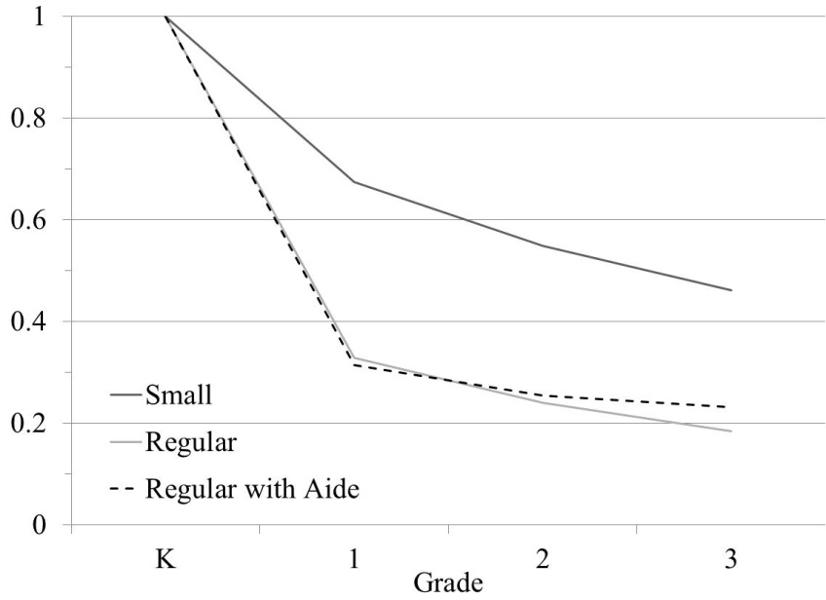 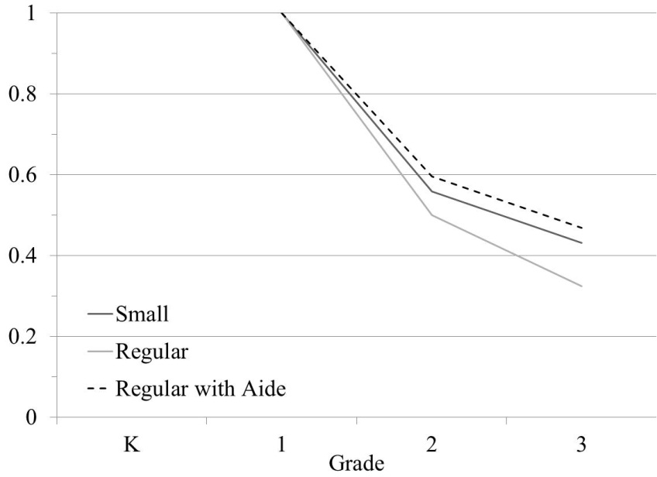

Panel C: Entered Project STAR in Grade 2

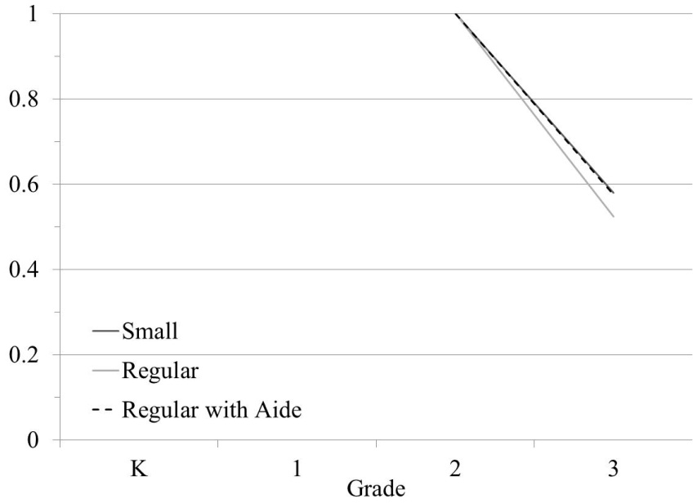

Notes to Figure 2: Data source is Tennessee STAR program data. Students from schools that left Project STAR are excluded from the sample. For the kindergarten entry cohort in panel A, much of the difference in attrition rates between small and other class types is attributable to a re-randomization of class types after the first year for students in regular and regular with aide classes. Additional details in the text.

Figure 3: Status in Third Grade by Year of Entry and Initial Class Assignment in Project STAR

Panel K-A: Entered in Grade K Panel K-B: Entered in Grade K Panel K-C: Entered in Grade K

Initially in Small Class Initially in Regular Class Initially in Regular Class w/ Aide

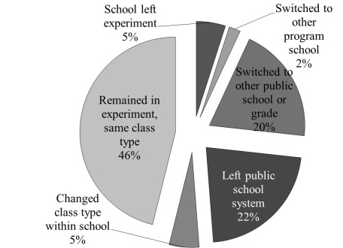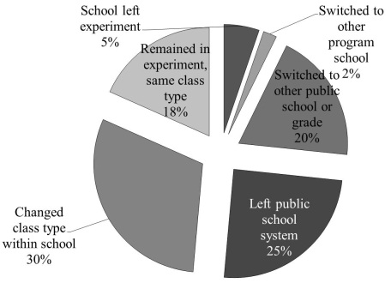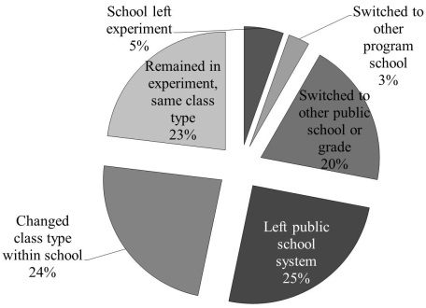

Panel 1-A: Entered in Grade 1 Panel 1-B: Entered in Grade 1 Panel 1-C: Entered in Grade 1

Initially in Small Class Initially in Regular Class Initially in Regular Class w/ Aide

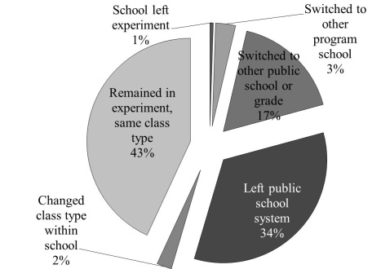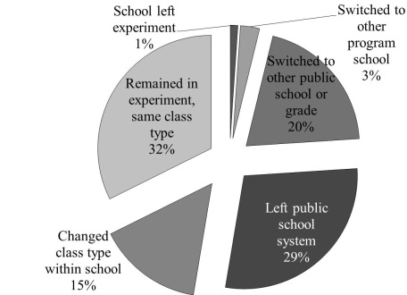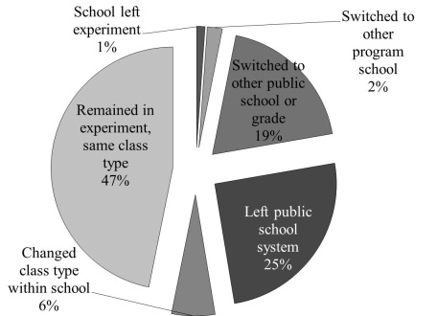

Panel 2-A: Entered in Grade 2 Panel 2-B: Entered in Grade 2 Panel 2-C: Entered in Grade 2

Initially in Small Class Initially in Regular Class Initially in Regular Class w/ Aide

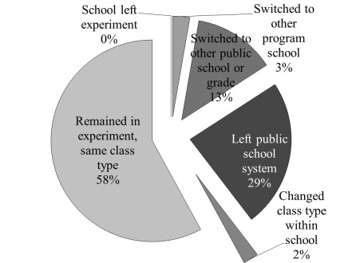 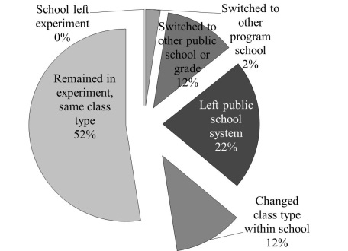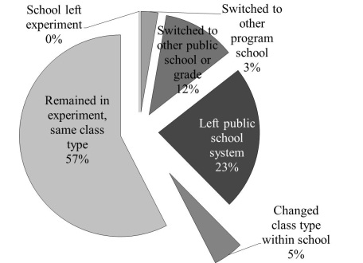

Notes to Figure 3: Students are counted as having left the public school system if they do not appear in Project STAR in third grade and TCAP scores are not available for them in 1990 (the year in which most students from the cohort were in fourth grade). Additional details in the text.

Figure 4: Transitions across Class Types within Project STAR Schools

Panel A: Entered Project STAR in Grade K Panel B: Entered Project STAR in Grade 2

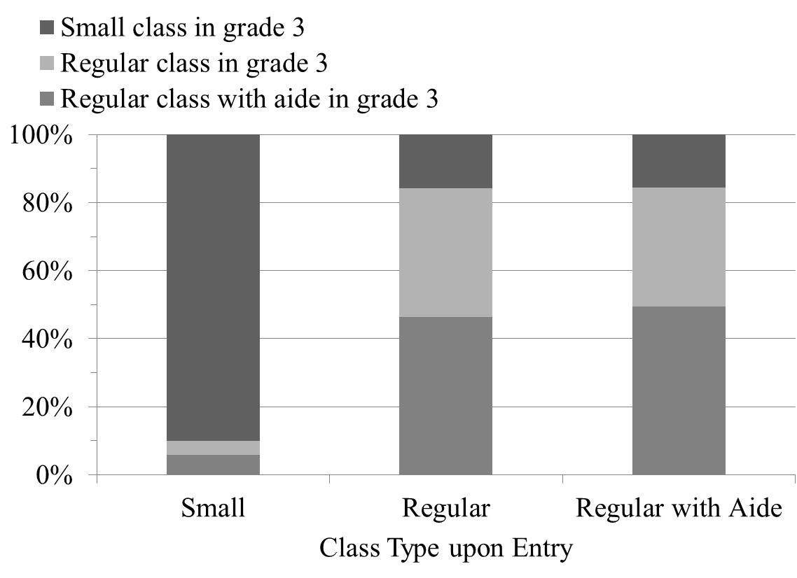 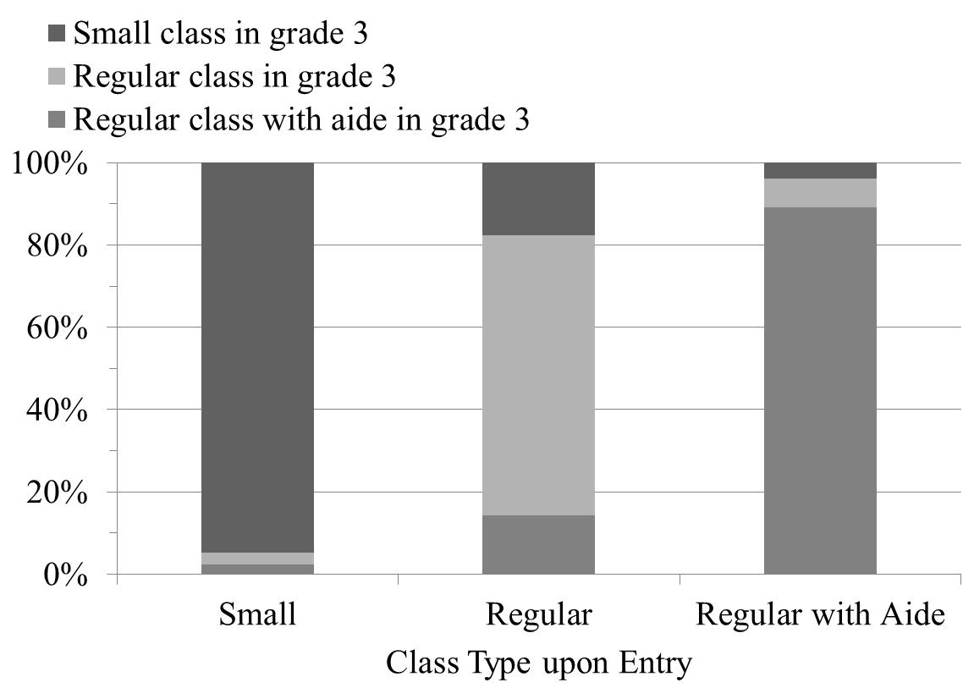

Panel C: Entered Project STAR in Grade 2

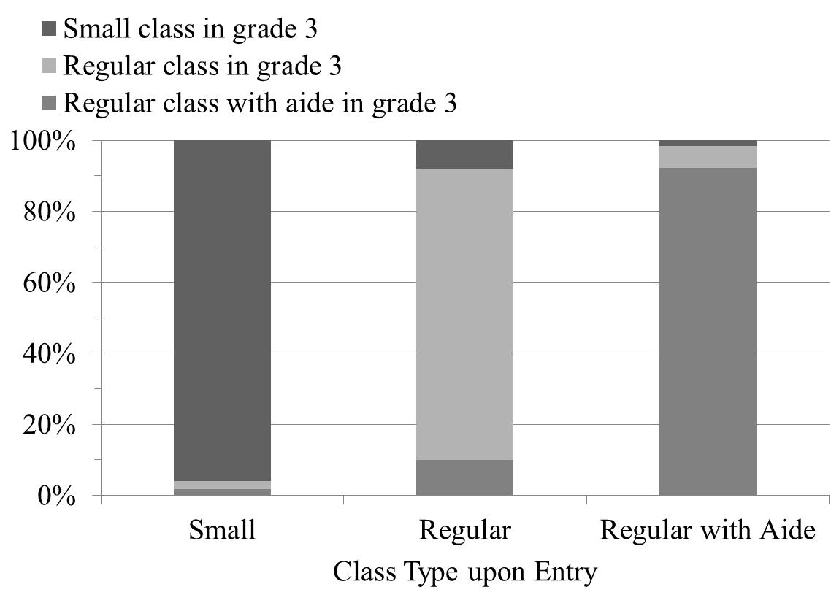

Notes to Figure 4: Sample is restricted to students who were in Project STAR in third grade in the same school as in the year of entry. Additional details in the text.

Figure 5: Grade Repetitionin Project STAR by Year of Entry and Initially Assigned Class Type

Panel A: Teacher Recommended Grade Repetition in Some Project STAR Year

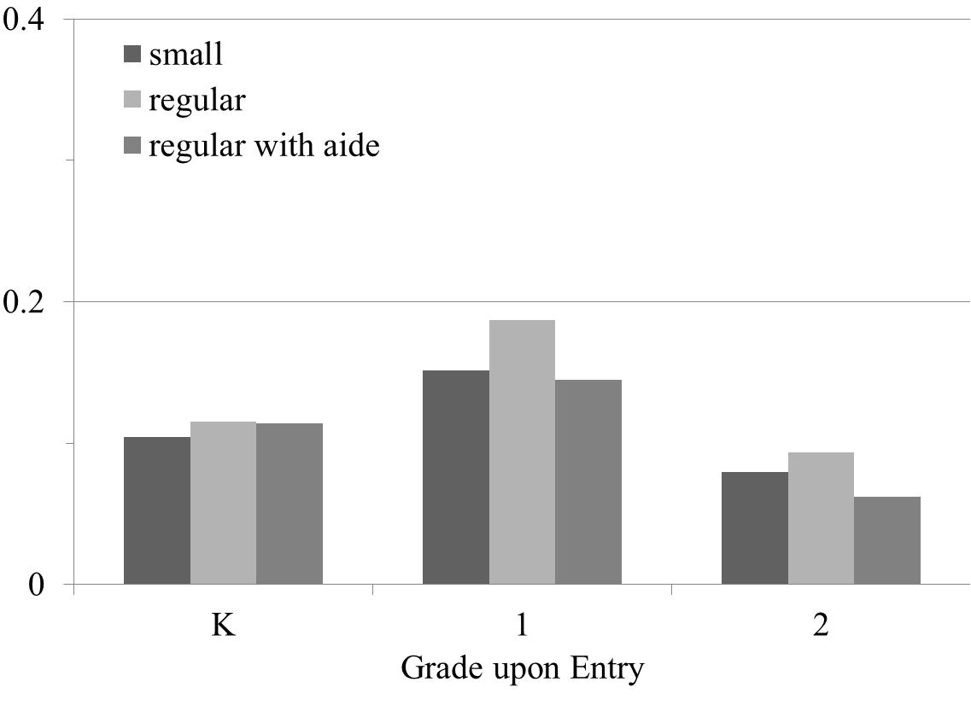

Panel B: Took TCAP in 1995 or Later

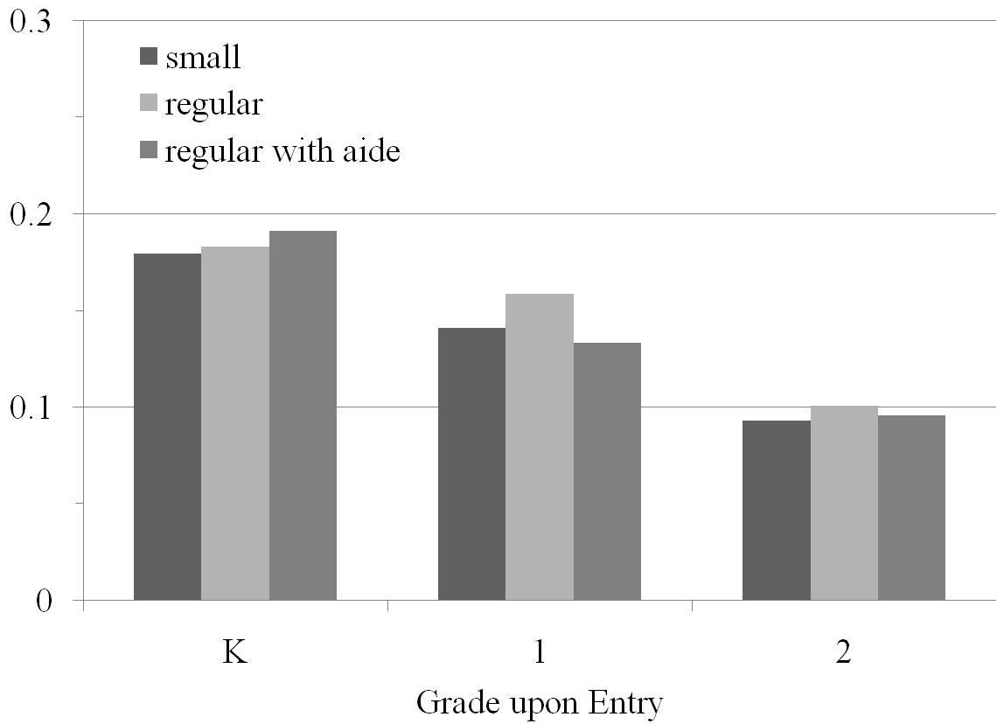

Notes to Figure 5: “Teacher recommended grade repetition” taken from Project STAR data; sample includes all students whose schools did not leave the program. Because the TCAP was only taken through eighth grade, a student in the STAR cohort who was making regular progress would not have taken the TCAP in 1995 or later. Hence, this outcome indicates that the student remained in the public school system through 1995 and repeated at least one grade.